CA NO. CWE/MTR/HSR(W)/66 OF 2018-19 Serial Page No. __

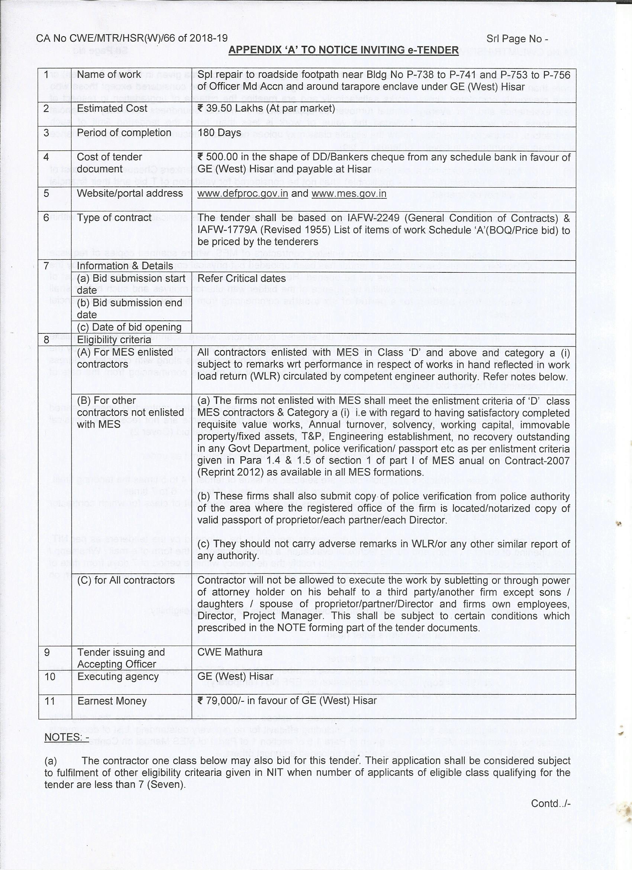

CA NO. CWE/MTR/HSR(W)/66 OF 2018-19 Serial Page No. __

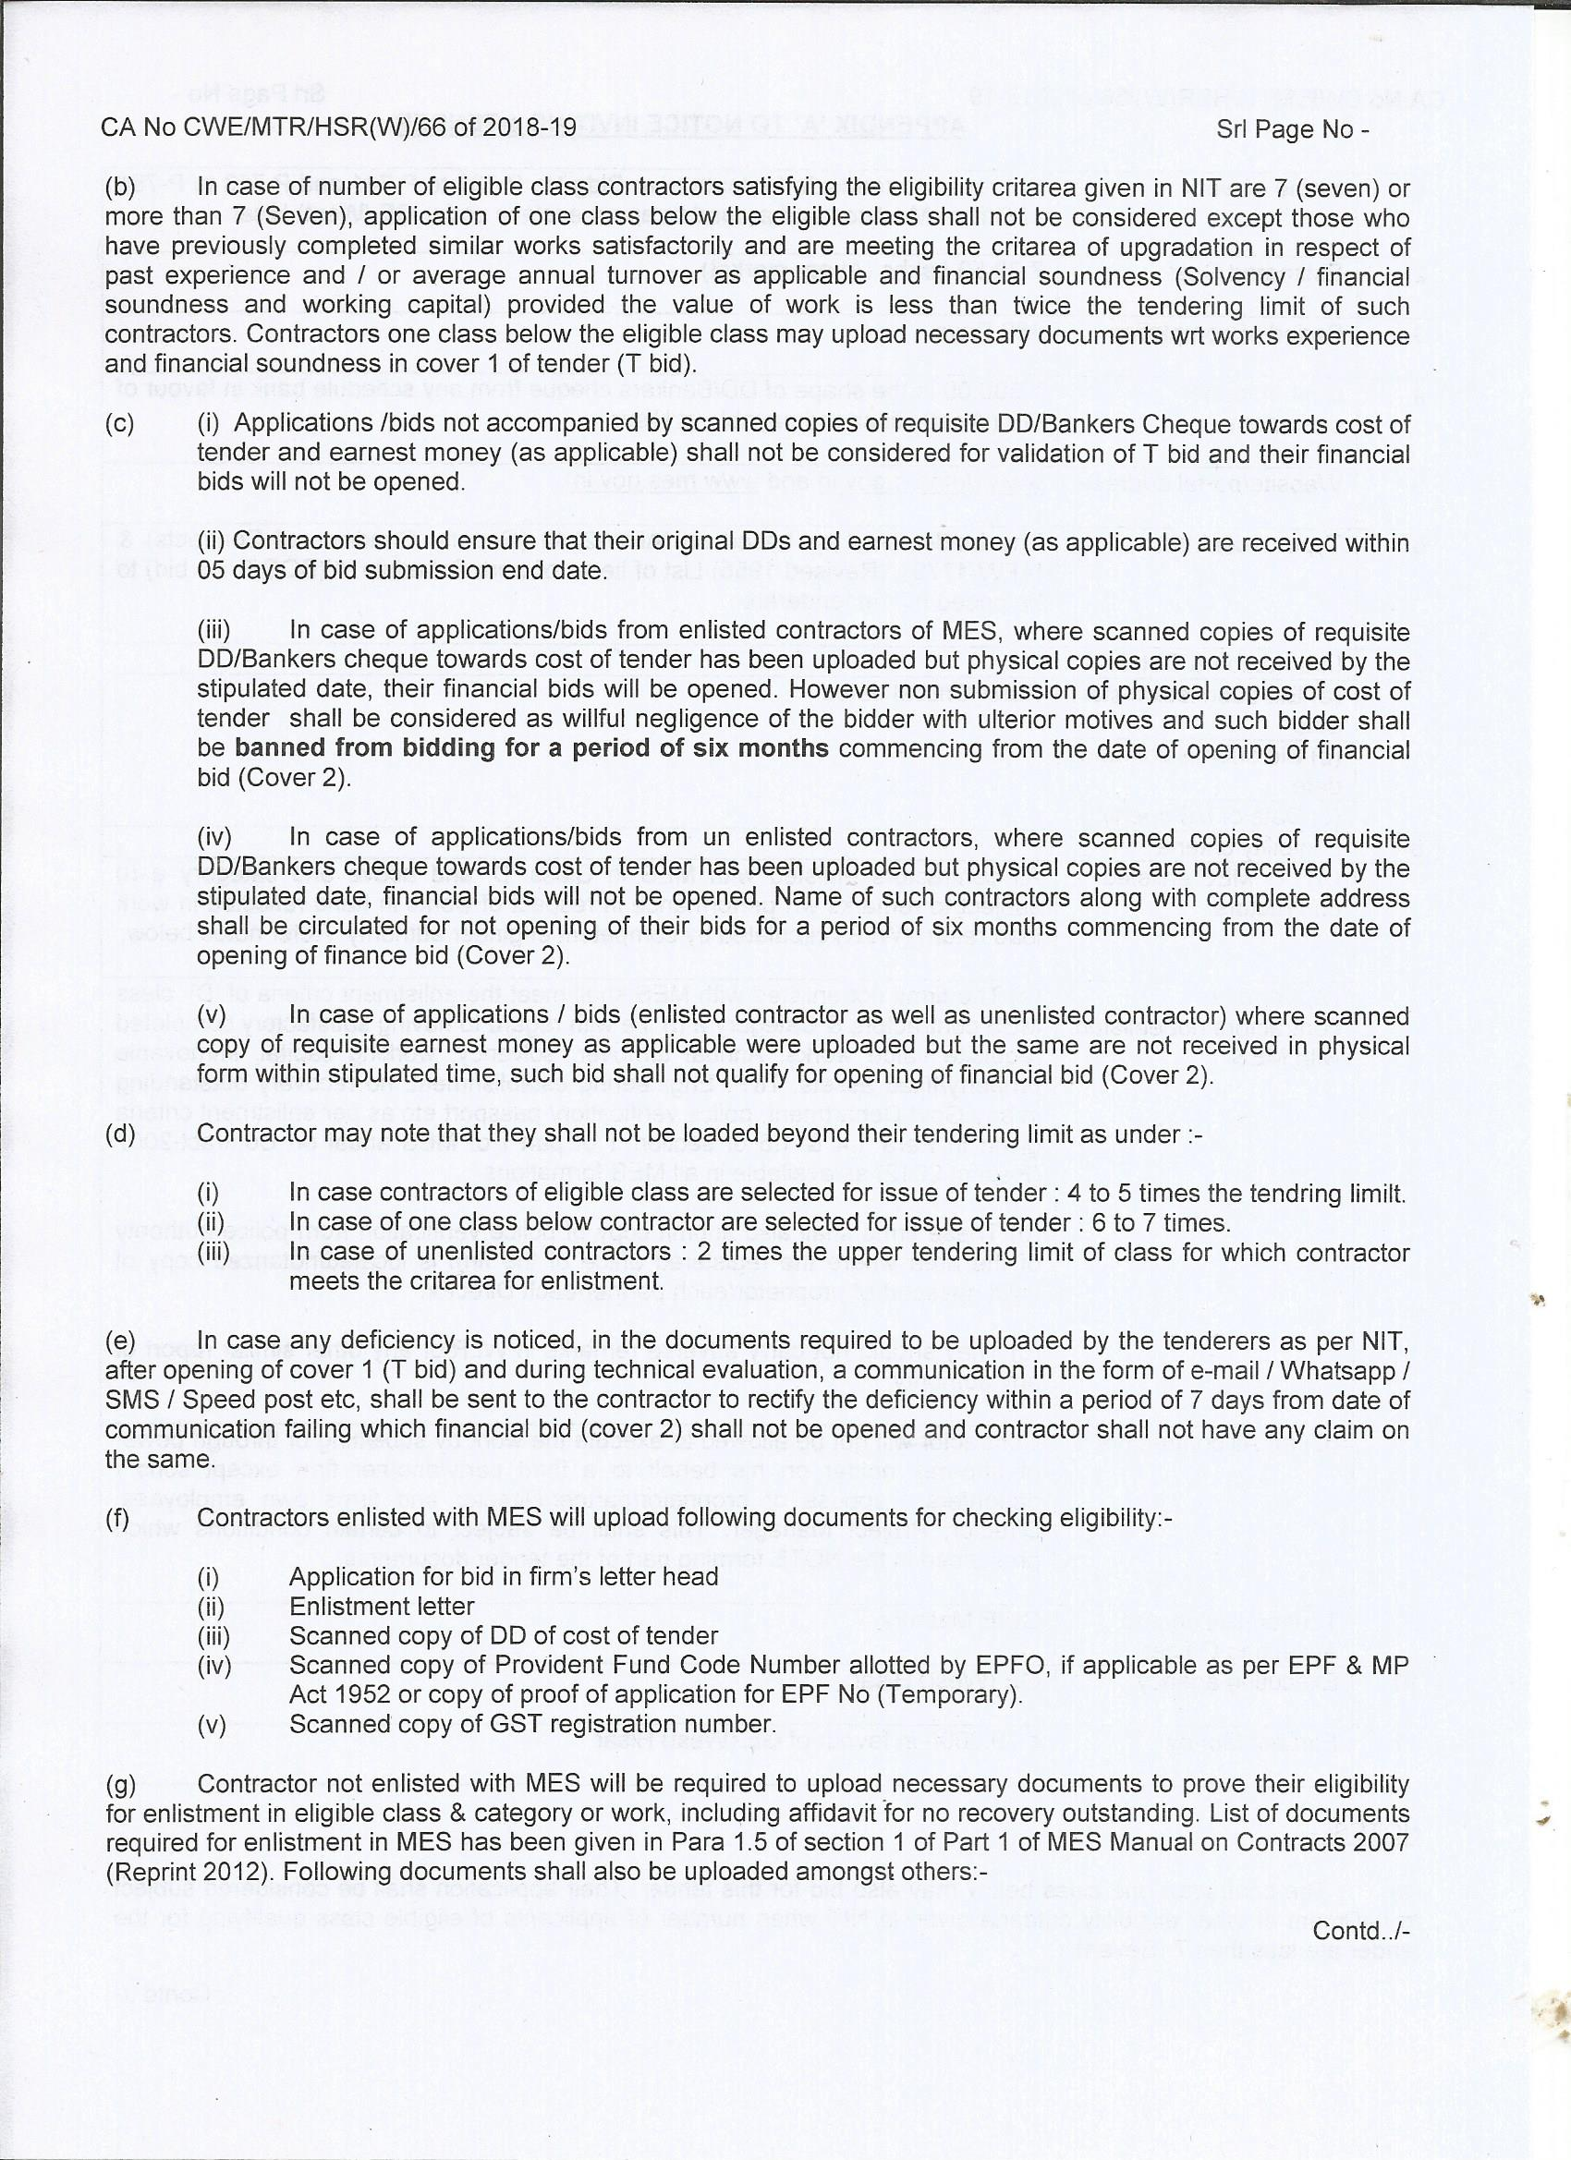

CA NO. CWE/MTR/HSR(W)/66 OF 2018-19 Serial Page No. __

